Churchwardens’ Annual Church Property Report

In accordance with The Parish Administration Act (2010), the Template below is to be:
- completed and signed off on by the Churchwardens;
- forwarded to the Registrar by October 31st each year; and
- presented at the Annual Parish Meeting.
This form should be considered when developing the annual parish budget. Note that all issues identified DO NOT need to be addressed at once, create a plan to tackle the highest risks first.
Building (eg: Rectory/church/hall) _______________________________________________________

Parish and location of Property ______________________________________________________

Complete visual inspection and tick / insert comments or rating where appropriate
(one report per building):

External
 | No visible problem | Further Inspection Required | Work to be undertaken | Risk rating
Roof
Guttering
Windows / Doors
Walls
Ground level perimeter
Steps/Ramps/Handrails
Land and gardens

Internal
 | No visible problem | Further Inspection Required | Work to be undertaken | Risk rating
Ceiling
Walls
Windows / Doors
Floor / Flooring
Furniture
Handrails

Nature of required work: __________________________________________________________________
_______________________________________________________________________________________

Timeline of required work:_________________________________________________________________
_______________________________________________________________________________________

Provision in Parish Budget: Yes / No

This form should form the basis of the Churchwardens’ report to the Annual Parish Meeting of the condition of all Church Property and work needing to be undertaken.

Churchwardens’ signatures

Date / / |  | Date / / |  | Date / /

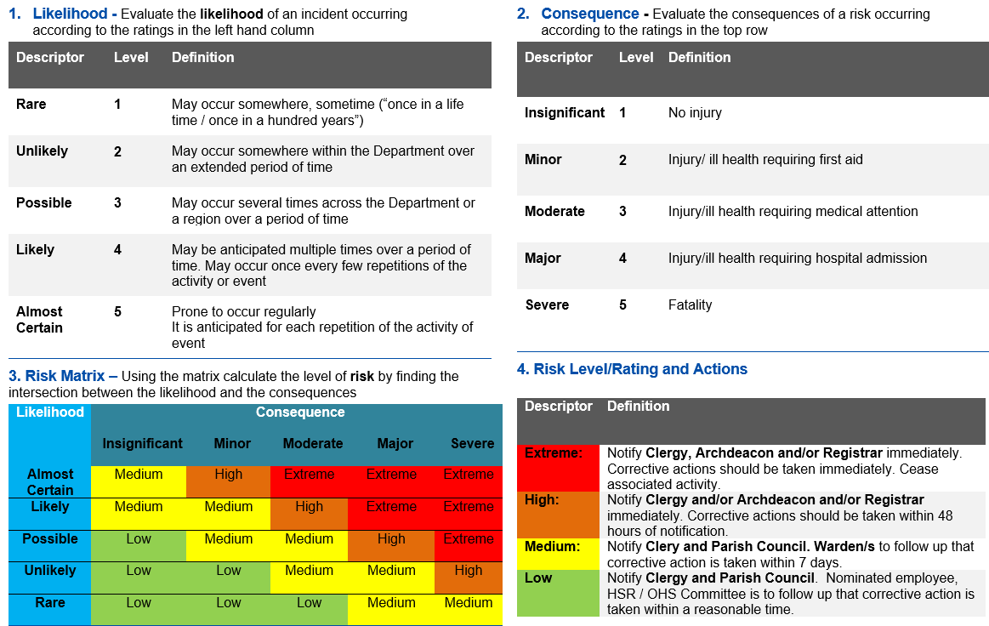
RISK RATING MATRIX

There is a Risk Matrix on page three to assist with Risk Ranking.

